**CHAPTER ONE**

**INTRODUCTION**

**1.1 BACKGROUND OF THE STUDY**

Computer and communication technology is the most advance electronic development, which has transformed almost all areas of human endeavor in the present generation. There is almost no field of study or industry, which has not felt a positive impact of the technological trends and development (Bredan, P.K 1992).

Computer technology continues to advance over the year reaching extensive ends and applications. One of such provision of computer technology is the internet. The internet is literarily understood as a global network of computers and allows communication device, which provide a wide range of services and sharing of various forms of resources. One of the provisions that have dominated the internet scene and forms (Bredan, P.K 1992). The main focus of this work is the “WORLD WIDE WEB”. The World Wide Web (WWW) as a major internet provisions is relatively complex and deserves a detailed discussion. Historically, it was a distributed information service developed in the early 1990’s at the European Laboratory for practical physics (CERN) Geneva. It is a large –scale distributed hypermedia system based on networked computer which are attached to integrated network known as the internet and allows access to document from remote areas via connected terminals and computers (Bredan, P.K 1992).

The necessity of an automate management information system, educational development as whole, both nationwide and internationally cannot be over emphasized. The unusual assertion by many professionals that “Information is power” is continually gaining affirmation and reaffirmation as the country continues to witness dynamic trends in information technology (Roberts, L. 1967).

The manual system of information management has serve for a long time now, but you can agree with me that it is not consistent enough, timely enough in the system, due to some physical and human constraints.

With the introduction to automated information system, data capturing, creating, processing, dissemination and storage are more efficient, effective and reliable and the final output in turn is satisfactory to the individuals concerned Roberts, L. (1967).

This project shall be administered to meet statutory regulatory and departmental requirement needs of the system. Automated information system has a level of security that commensurate with the risk and magnitude of the harm that could result, from the loss, misuse disclosure or modification of the information contained in the system. Each system’s level of security must protect the confidentiality, integrity and availability of the information produced (Chidambaram, L. et al 1993). The privacy Act of 1974 in the United States of America imposes strict limitation on the school authority to disclose or rough handle information maintained on individuals without their prior consent (Chidambaram, L. et al 1993).

This information system has the capacity to handle any amount of data produced without complexities. Record keeping in far more complex in school today than in the past because of the incriminating rate at which students are admitted each session. For this reason technological advances have been made available to provide an ultimate way for meeting information requirement as regards to education (Gleason, T. 1994).

**1.2 STATEMENT OF THE PROBLEM**

Due to the increasing number of students in recent years and some human limitations, lots of problems have been encounter. These problems include:

1. Problem of proper registration of courses going by the laid down rules.

* Students registering of course onside the option in which the study.
* Students omitting carry over/reference course during result compilation.
* Students offering more/less credit load than required.
* Lack of adequate guidance in course registration.

The following short comings result in student having extra years or semester apart from the stipulated years.

1. The problem of detecting omitted result.
2. Stress in computation of result considering the increasing number of students.
3. Problem of switching results/registration of number of students before compilation.
4. Problem of getting results ready at the appropriate time to enable students register carry-over courses.
   1. **AIMS & OBJECTIVE OF THE STUDY**

The aim of this project is intended to design code and implement an online management information system that will keep track of all the records needed to computer students for easy accessibility to results and on-line registration of courses.

The objectives are as follows:

1. To restrict the registration of courses based on the mistake of registering the wrong course.
2. To make students readily have access to their result from remote destination at appropriate time.
3. To make results more reliable
4. To provide security measures to avoid missing results.
5. To avoid tampering of results by unauthorized user.
6. To eliminate the problem of switching results.

**1.4 SCOPE AND LIMITAION OF STUDY**

This project is based only on the analysis made at the department of computer science in Moshood Abiola polytechnic. The on-line system can only be used by the department and students in the department. With some amendments other departments can make use of this application.

Nevertheless this project is limited to automated accessing of students result once entries are made and also on-line registration of appropriate course for each semester. This on-line management information system produces report for only 100 to 400 level student (Full-Time) in the department. It should also be noted that this project is not based in designing automated management information system for department of computer science but thoroughly deals with how students register and process results.

**1.5 SIGNIFICANCE OF THE STUDY**

It is critical for this project to be undertake in order to provide better recording system which can be accessed over the internet from remote destinations, and also allow accurate on-line registration of courses and processing of results also.

This will eventually provide a more organized result recording system and will tend to clear off doubts and fears about the standard of education in the system and the level of knowledge acquired by the students produced by the department. Also serves as a channel of communication between the students, staff and the entire world.

* 1. **DEFINITION OF TERMS**

1. **Automation:** is the theory, art and technique of converting a mechanical process to maximize automate operation specially by the use of electronic control mechanisms and electronic computers for the rapid organizing and processing of data in a wide range of technical industrial and business information.

Also automate means to control by information to change or convert to.

1. **Program:** it is a set logically related instructions that are in sequence and are used to giving solution to specific problems. It is a set of instructions given to the computers to perform a specific task.
2. **Information:** this simply means processed data.
3. **Data:** these are raw facts that are not yet processed.
4. **Computer:** this is an electronic device that is capable of solving problem by accepting data, processing them and producing results.
5. **Registration:** this is an alphanumeric code used to identify each candidate in the various departments.
6. **Form :** this is in form of a paper, which requests the candidate to fill in some requirements needed by the institution.
7. **ADI** : term used to denote application programming interface. A defined set of technologies different programming application.
8. **File size** :how large the file containing the data is, usually measured in kilobytes or megabytes.
9. **Byte** : abbreviation of binary term.
10. **Frames** : formatting a page so that more than one HYML document is visible on the screen at the same time.
11. **HTTP** : A protocol to transfer hypertext requests an information between serves and browses.
12. **Internet** : A geographical interconnection of computer together to allow them to exchange data, allowing for service like the database and web.

**CHAPTER TWO**

**LITERATURE REVIEW**

**2.1 HISTORICAL BACKGROUND OF THE STUDY**

The introduction of computer into information technology has massively improved the information needs of organization. French (1992), in his book titled” computer Science” fourth edition, he relates the relevance of computer to management and stated that “a company needs information in which to base decisions concerning the current operations and future plans. It requires the information to be timely and accurate”. He then cited the example of the use of computer in the area of management control to production and stated “production must be able to respond quickly to changes in demand and other circumstances. To do so requires the provision of up to date information this is accurate and timely”. Aluko (1991), stated that “in virtually any job whether clerical, technical, business, or professional; whether it is a banking, medicine, education etc.

Computers are useful tools” and that “computers are tools with which we calculate, measure, assess, store, retrieve, regulate and monitor information”. Hence, the blood and life – wire of any system is information. A typical system (Education, Management etc.) cannot survive without good management information system (MIS). Management information system (MIS) are information systems, typically computer- based, that are used within an organization. The concept of management information system is a complex variable although Murdick (1971), simplified it when he said “there is probably no more challenging and diversified subject than management theory, system theory and computer science”. Admission processing system, result processing system, course registration system is typical information processing system or organizational information system on candidates’ admission and performances.

World Net describes an information system (I.S) as “a system consisting of the network of all communication channels used within an organization, and includes software and hardware”. It may also be defined as “a system that collects and processes data (information) and provides it to managers at all levels that use it for decision making, planning, program implementation and control. The aim of information system to admission, registration and result processing in polytechnics is improving the quality and accuracy of information provided to all involved as well as assisting polytechnics in compiling and reporting information.

The information system (IS) has common data set on admission, admittance regulations of different polytechnics and admission procedures. Computerization is a social process for providing access to and support for computer equipment to be used in activities such as teaching, accounting, writing, designing, circuits, file processing etc. Computerization entails social choices about the levels of appropriate investment and control over equipment and expertise, as well as choices of equipment.

Kling (1991), by the early 1990s, computing and telecommunications accounted for half of the capital investments made by private firms. However, paper Feigenbaum(1980) and McCorduck (1983) and Yourdon (1986) stated that the most fervent advocates of computerization have argued that the actual pace of computerization in schools, factories and homes is too slow. Taylor (1980), classified computer-based education as to include both computer-assisted instruction programs that interact with students in a dialogue and a broader array of educational computer applications such as simulations or instruction in computer programming. There is major national push for extended application of computer-based education at educational levels. For example, in the mid 1980s private several colleges and Polytechnics required all their fresh students to buy a specific kind of Micro-computers and others invested heavily in visions of “wired Campus”.

Kling (1983) asserts that computer-based education has been promoted with two different underlying ideologies in all levels of education. Some educators argue that computer- based instructional approaches can help fulfill the traditional values of progressive education: the simulation of intellectual curiosity, initiative, and democratic experiences. For examples, (1984) has argued that computerized polytechnics are qualitatively different than traditional polytechnics: College students with micro computers in their dorm rooms, will stimulate them to learn because they will have easy access to instructional materials and more interesting problems to solve. Papert (1979), argues that in a new computer – based school students will no longer simply be taught mathematics. These visions portray an enchanted social order transformed by advanced computing technologies. Other advocates are a bit less romantic, but not less enthusiastic.

For example Cole (1972), states that because of the insatiable desire of students for more and more information at a higher level of complexity and more sophisticated level of utilization, more effective means of communication must be used so that Computers can provide a unique vehicle for this transmission. Hence, it is important to note that computer- based education goes a long way in helping the students as well as the staff to effectively make use of the computerized course registration system. It also helps in convincing the stakeholders of the importance and need for adopting the computerized admission, registration and result processing system as it provides effective and accurate handling of student’s files.

A computerized course registration system is usually a system, which is implemented with a computer to achieve the utmost efficiency and desired goals. In well developed countries, where education systems are computerized; course registration system should be and/or is one of the modules contained in the college portal. A “College Portal” therefore is personalized software that captures the entire education business process and makes all operations accessible via the web, thus allowing schools to effectively serve all stakeholders, students, lecturers, administrators and parents. It provides many functionalities including Admissions, Registration, Financial Services (transactions- processing), Exams & Records, Grading, Staff Management, Facility Management, Student self-care (My school), Alumni Records, Library and College shop, etc and supports workflow and Messaging and provides other collaboration tools and advanced reporting engines. Russell, M. (1987), dealt extensively on the need for the use of computers on such database system like computerized course registration system. In the words of Dimorji (2003), at the center of any information system is a database, which is any collection of related information grouped together as a simple item. The term can also be applied to the ways in which information in catalog is used, analyzed, stored and used manually. Russell was also of the view that without a computer, effective handling of Candidates’ records cannot be achieved effectively. According to him, “The oxford University has more than ninety- six thousand student’s records. No person would precisely remember the details of these records”.

The computer is the most possible application to retain an unlimited number of records with the utmost current updating possibilities. This is true as can be seen as posited by Eloba (1992), Computer in school record keeping, Technical Education Today, Vol. 3 No 182. “That at a department with over a thousand candidates, with the use of computer, all qualified for admission, only 100 candidates needed to be chosen. With the ranking of the scores or grades of the candidates, the management is in position to choose the best candidates with the best results with ease and on time” with the use of computer. Again, many computerized systems have become more than tools-they are environments that people sometimes find hard to change and so on. Kling and Suzanne (1988), argue that we have much to learn about future uses and consequences of computerization by carefully examining past and present experiences. Knowing fully well how the Polytechnics program is being run (manually), studying the past and present experiences, energize the idea of computerization of the board or the program.

Also, Kling, (1994) illustrates that systems being computerized offers exciting possibilities of manipulating large amount of information rapidly with little effort to enhance control, to create insights, to search for information, and to facilitate cooperative work between people.

* 1. **STUDENT RESULT GUIDE**

When a student attends an academic institution (s), a record is kept which traces his/her academic history. The students’ examination Result displays a record of all the credit and grades a student has acquired at each school attended. Below are frequently asked questions about students examination Results. By all students:

Student can use a student’s examination Result as a means of monitoring their credit classes and grades and to make sure the information is accurate. Students use an “Unofficial student’s examination Result “for this purpose. When a student is applying to another college or polytechnics, enrolling institution will require for an official students examination Result so that credits can be evaluated by the enrolling institution. An enrolling institution conducts a student's examination result evaluation to place a student at his or her appropriate academic level. Student must request their students’ examination Result from the office of Record or from the office of the Registrar. Each school has its own student’s examination Result release procedures. Because students examination Result requests are covered by the family Educational Rights and privacy.

Act, students ( giving name, date of attendance ,and social security number), or provide proper documentation when appearing in person often schools provide a “Request for official students examination Result “form .A small fee is usually charged .The difference between official and unofficial students examination Result is that ,official students examination Result must meet certain standards and be sent directly from one institution to another .In some cases, the college will accept an official students examination Result from the student if it hand delivered in a sealed envelope. Unofficial students’ examination Result can be sent directly to a requesting student. It could be marked as an unofficial student’s examination Result or issued to students but not all schools issue these. Each school has its own transfer credit acceptance policies. Credit transfer problems can result if:

* An institution does not have proper accreditation.
* Certain courses are taken (e.g. base skills or physical education courses) that are not approved for transfer.
* The amount of credit hours earned exceeds the maximum amount the institution will transfer.
* The enrolling institution has a difficult time evaluating a course.
* The course work is over 10years old. Polytechnics often require appreciate catalogs or course descriptions.
  1. **DATA PROCESSING**

This is generally the collection and manipulation of items of data to produce meaningful information.

**2.3.1 Education Processing System:** Monroe (2011) cited that educational management is a comprehensive effort dealing with the educational practices. It is the dynamic side of education which deals with educational institutions right from the schools and colleges to the secretariat and is concerned with both human and material resources. The purpose of educational management is to bring pupils and teachers in a condition that will more successfully promote the realization of the objective of education. Balfour (2011) stated that the purpose of educational management is to enable the right pupils to receive the right education from the right teachers, at a cost within the means of the state, which will enable pupils to profit from their learning.

Educational Management Information System is designed to manage information about the education system and to put it to use. Hua et al.(2003) stress that EMIS is a set of formalized and integrated operational processes, procedures, and cooperative agreements by which data and information about schools and schooling, such as facilities, teachers, students, learning activities, and evaluative outputs, are regularly shared, integrated, analyzed, and disseminated for educational decision purposes that is use data every level of the educational hierarchy.

The success of EMIS development can be measured and in terms of 3factors: timely and reliable production of data and information, data integration and data sharing among departments, and effective use of data and information for educational policy decisions. Hua et al.(2003) Conclude that in order to achieve the first factor for the success of EMIS, data production should be produced regularly that must meet the needs of overall educational planning and budgeting cycle, educational services, educational monitoring, evaluation and policy research and guidance in a timely fashion and must meet the needs of international collaboration and communication. The authors further explained that the timelines of meeting these needs is critically important for the success of an EMIS development and that EMIS data must Come up with reliable reports from the current reality, status or trend of change of educational development of the country, district or school.

The level of data reliability can be affected by almost all elements of data and information production procedures, which include the design of data collection instruments, clarity of question items, field data collection methods, educational and ethical level of respondents, design of computer database applications, data entry procedures, data aggregation methods, data integration procedures and analytical and data processing capacity. No amount of technological innovation can enhance data and information that is poor in quality from the outset. Hua et al. (2003) likewise mentioned that data integration is one of the most important parts of EMIS development, which means that data from multiple sources (payroll, achievement, and school census), multiple years, and multiple levels (student, teacher, or school level) can be linked together.

**2.3.2 Computer Data Processing:** This is any process that uses a computer program to enter data and summarize, analyze or otherwise convert data into usable information. The process may be automated and run on a computer. It involves recording, analyzing, sorting, summarizing, calculating, disseminating and storing data. Because data is most useful when it is well-presented and it is also informative .Data-processing systems are often referred to as information systems. Nevertheless, the terms are roughly synonymous, performing similar conversions; data-processing systems typically manipulate raw data into information, and likewise information systems typically take raw data as input to produce information as output. Data processing may or may not be distinguished from data conversion, when the process is merely to convert data to another format, and does not involve any data manipulation.

**2.3.3 Data Analysis:** When the domain from which the data are harvested is a science or an engineering field, data processing and information systems are considered terms that are too broad and the more specialized term [data analysis](http://en.wikipedia.org/wiki/Data_analysis) is typically used. This is a focus on the highly-specialized and highly-accurate algorithmic derivations and statistical calculations that are less often observed in the typical general business environment. In these contexts data analyses packages like [DAP](http://en.wikipedia.org/wiki/DAP_(software)), or [PSPP](http://en.wikipedia.org/wiki/PSPP) are often used. This divergence of culture is exhibited in the typical numerical representations used in data processing versus numerical; data processing's measurements are typically represented by [integers](http://en.wikipedia.org/wiki/Integer) or by [fixed-point](http://en.wikipedia.org/wiki/Fixed-point_arithmetic) or [binary-coded decimal](http://en.wikipedia.org/wiki/Binary-coded_decimal) representations of numbers whereas the majority of data analysis's measurements are often represented by [floating-point](http://en.wikipedia.org/wiki/Floating-point) representation of rational numbers (Anigbogu, 2002).

**2.3.4 Processing:** Practically all naturally occurring processes can be viewed as examples of [data processing systems](http://en.wikipedia.org/wiki/Data_processing_system) where "observable" information in the form of [pressure](http://en.wikipedia.org/wiki/Pressure), [light](http://en.wikipedia.org/wiki/Light), etc. are converted by human [observers](http://en.wikipedia.org/wiki/Observation) into [electrical](http://en.wikipedia.org/wiki/Electrical) signals in the [nervous system](http://en.wikipedia.org/wiki/Nervous_system) as the [senses](http://en.wikipedia.org/wiki/Sense) we recognize as [touch](http://en.wikipedia.org/wiki/Somatosensory_system), [sound](http://en.wikipedia.org/wiki/Sound), and [vision](http://en.wikipedia.org/wiki/Visual_perception). Even the interaction of non-living systems may be viewed in this way as rudimentary [information processing systems](http://en.wikipedia.org/wiki/Information_processing_system). Conventional usage of the terms data processing and information systems restricts their use to refer to the algorithmic derivations, logical deductions, and statistical calculations that recur perennially in general business environments, rather than in the more expansive sense of all conversions of real-world measurements into real-world information say, an organic biological system. Frederick (1916), first governor of the unified colony, set up a school inspectorate. Discipline, buildings, and adequacy of teaching staff were to be inspected, but the most points given to a school's performance went to the numbers and rankings of its examination results. This stress on examinations was still used in 1990 to judge educational results and to obtain qualifications for jobs in government and the private sector.

As more information is made available in a variety of formats and media and in a variety of locations, the need to manage information/data efficiently becomes more and more critical. Both staff and public users want access to stored information and want to access it more efficiently. It is the University Policy to improve both the efficiency and effectiveness of course registration and result processing operations and services through the implementation of an integrated automated database System. Together with the emergence of the leadership and management practices to take advantages of these “flatteners”, and the collapse of political and economic barriers that accompanied the end of the cold war, what Friedman calls the “triple convergence” has literally “changed everything”. Friedman’s observations are supported by the words of the CEO of Hewlett Packard, that the world is entering “an era in which technology will literally transform every aspect of business, every aspect of life and every aspect of society.

**2.3.5 PROBLEMS ASSOCIATED WITH DATA PROCESSING**

There are problems with data processing with respect to Computer. The problems are the same as those problems encountered when using Computer.

The major problem is:

Hardware failure which may be caused by power (supply of current).

**2.4 RESULT PROCESSING SYSTEM**

Computers are a key features of the electronic office, and it is important aware of the reasons why they process information better than a manual system. The functions of computers in information or data or result processing include:

1. To process information or result more quickly
2. To handle bigger volumes of processing
3. To undertake complex processing
4. To process information more reliably i.e. with less chance of error\mistakes
5. To process information at less cost than a manual system.
6. To improve the scope and quality of management information

**2.4.1 FORMATS OF RESULT**

Result must be communicated to the person who wishes to use it. It can be communicated in a number of ways for example:

1. By word of mouth (e.g. telephone) by sight (e.g. witnessing or observing something) even by touch, smell or taste
2. On paper
   * 1. as a report
     2. as a set of figures
     3. as a diagram or chart
     4. as a photography or picture
3. In a form that is not human sensible, or in a form that humans cannot use without the help of a computer or special equipment. Microfilm and microfiche are examples of this and computer files of magnetic disks, or magnetic tapes are others. The communication of the information would, in these cases, be communications between machines and humans would then have to use a machine such as a computer or microfilm reader to obtain access to the information they want. Information and organization are unified. Information is communicated so that decisions can be taken.

**2.4.2 THE FEATURES OF RESULT PROCESSING**

Processing business data can be said to have the following features for manual as well as electronic. The features are:

**1. Collecting Data in the First Place**: There must be data to processed and this may arise in the course of operations. There has to be a system or procedure for ensuring that all the data needed for processing is collected and made available for processing.

**2. Up-Dating Files to Incorporate the Processed Data**: Updating the personal ledger and the debtors control account are the updating activities to keep the sales ledger records up to date. Updating files means bringing them up to date.

**3. The Routine Dissemination of Information to Users**: This includes routine management control of information and comparing the actual results budgeted for the month. Providing non-routine information to users on request.

**2.4.3 TYPES OF RESULT PROCESSING**

Basically there are two types of result processing: the conventional result (manual) processing and electronic method of result processing. Result can be processed manually or with the aid of primitive tools such as tabs or calculators, which take heavy tools in manual input. The processing of result by machines in general in such a way as to reduce to a minimum level the need for manual processing is referred to as automatic data processing (ADP). When result processing is mainly done by computers we refer to this as electronic data processing (EDP).

Generally the result processing methods are:

**a. Manually Method:** This involves operations performed by a clerk, assisted if desired by specific aids such as a pocket calculator or adding machine etc. this method processing is only suitable in cases where the volume of result to be processed is small and there is not too much emphasis on the specific period of time the work must be completed. The processing is simple and in most cases, the employment of more hands will solve the problem of time constraint. Example is the updating of handwritten result records.

**b. Mechanical Method**: This involves operations that are performed by machine consisting of a keyboard but which are actuated by depressing appropriate key by an operator. The results of this type of processing are printed on documents in specific columns. Example is the posting of lodgments and withdrawal on the personal customers’ ledger using an accounting machine.

**c. Electronic Method**: This is more or less like the mechanical method except that in this case the machine being used is electronic and may have optional peripheral devices that are attached to it. It can be can be used for many accounting procedures including payroll, stock schedules and ledger updating. These days’ computers are being used. Result for input are entered through the keyboard, card reader, optical character/mark reader, tape reader, while processed result are printed or stored on auxiliary storage. Its processing speed is high and can therefore handle quite a large amount of result. Very suitable for processing tasks that are repetitive in nature.

**2.4.4 THE BASIC FEATURES OF RESULT PROCESSING**

Result processing is the term for the process of producing meaningful information by collecting all items of result together and performing operations on them to extract the required result from them. At one time, electro-mechanical devices were widely used for result processing but the advent of versatile microcomputers hastened their demise (Eloba, 1998).

**2.4.5 FACTORS DETERMINING THE METHODS OF RESULT PROCESSING**

Common factors determining the methods of result processing can be under the following headings:

**a. Size and Type of Results:** with each of the examples given, the method of producing the result will largely depend on the size and type of result. In a very small school a single person may be able to have the time to produce all the result required, but as the volume of result increases, more people and aids, in form of calculators and small computers, may be employed. Large volumes of result will require the use of large computers. In small schools the payroll will be a matter of simply paying a member of staff the same amount each month, whilst in others, a complex payment by results system will have to be coped with. Similarly, invoicing may be simply be a matter of virtually copying from the customer’s order, or it may require complex discount calculation. Simple situations indicate the need for fewer people and aid to produce the information and complex situations indicate the need for more people and aids (French, 1992).

**b. Timing Aspects:**  Some results requirements are less time critical than others. For example, the results for a semester may only be produced once in three months. The timing requirement for information will have considerable bearing on the methods and equipment needed to provide it.

**2.4.6 RESULT PROCESSING STAGES**

Whatever method, or combination of methods, is used it will be seen that result will pass through the same basic stages in the processing cycles.

The result processing stages are:

Input (act of receiving result for processing)

* Sorting (arranging result in a desired order to make processing quicker and easier)
* Processing (operating on result in order to obtain desired result)
* Storage (filling away of result for later use).
* Output result of processing.
* Control (regulating the different result processing functions to ensure that the result is being processed effectively).

**2.4.7 MODES OF RESULT PROCESSING**

The modes of result processing are as follow:

**1. Batch Processing:**  It is a technique by which items to be processed must be coded and collected into groups or batches prior to processing. A batch consists of either a convenient number of records or a collection of records relating to a given period, i.e. daily, weekly, monthly, etc. accumulated until a sufficient number are present to justify mass updating of master file. Each batch is used to update master file using a file maintenance program and an output produced. This type of processing is suitable for semester result and business applications, in which output is produced according to a predetermined processing cycle. The processing for this type of system is ordinary defined by the frequency with which the aster file must be updated. The average cost of processing results is low. No additional hardware, such as terminals or direct access storage devices, is needed. The system lends itself to control, as trailer records can be input which contain totals of important fields. The methods are secure as updating by copying can be used. It does, however, impose rigidity on the school. Weekly or monthly deadlines have to be met when peaks of work occur. Result is only up-to-date as the time of the result collection of the past update run; result is only produced once a period.

**2. Real time Processing:** Real-time = immediately. The processing of result in a sufficiently rapid manner so that the results of the processing are available in time to influence the current activity or process being monitored or controlled. The processing is applied to the master file as they happen and result is obtained from the system on demand.

**3.On-line Processing:** It concerns the equipment which is connected or re-engaged and functioning with the CPU and main program e.g. teletype units, consoles, card-reader, OCR readers, VDU etc. it is at least a one-way communication between operators at terminal and the CPU.

**4. Time-sharing Processing:**  The system interacts with many users, giving each of them fast individual attention on a time slice basis. Multiprogramming is necessary in a time-sharing system (Murdick, 1971).

**2.4.8 RESULT TRANSMISSION**

Result can be fed into the computer in any one of three modes:

a). **Simplex**: A simplex line allows result to be transmitted in one direction and one direction only. These simplex lines may be used to connect result collection terminals to distant computer systems, thus speeding the flow of result from these on-line input terminals.

**b). Half-Duplex:** A half-duplex line is one in which result can be transmitted in either direction, but in only one direction at a time, the flow of result in one direction must stop before result may flow in the opposite direction. Such lines may be used in time sharing operations.

**c). Full Duplex:** A duplex line is one in which result can be transmitted simultaneously both directions. Input/output (I/O) operations can be completed simultaneously. Such lines serve best in real time systems handling large volume of I/O transmission encouraging rapid distribution of result.

**2.4.9 METHODS OF RESULT PROCESSING**

The methods of result processing are categorized into:

**1. CENTRALISED RESULT PROCESSING**

Centralized result refers to as data processing which is carried out by a centralized location, such as head office. The data for processing might be gathered from a wide area, such as from all local offices the output might be sent out over a wide area too. But the actual processing and the possession of the data files are centralized. Data might be fed in to the central processing system either by physical transporting data records from their source to the central location, or electronically, to a remote terminal in the local office, linked to the central computer. Centralized processing is generally associated with a single computer, perhaps a mainframe or minicomputer being used for all the computer data processing in a school. It has the advantage of simplicity, low cost, elimination of duplicate computer hardware and efficient use of data processing resources.

Data fed in from a wide area

Central files

Central processing

Output distributed from the

central location

**Figure 1:** Centralized Data Processing

**2. DECENTRALISED RESULT PROCESSING**

In the decentralized data processing, each locality or department is provided with a computer system and does not necessarily have any thing in common. Each center handles its own data processing needs and generally does not interact with any other division or centers. It quickly responds to divisional needs and suits a decentralized management scheme. However, it is expensive on account of duplication of facilities and files. Here processing in a department is independent of one another, (Osaula, 1978).

Dept A

Dept B

Dept C

**Figure 2:** Decentralized Data Processing

**3. DISTRIBUTED RESULT PROCESSING SYSTEM**

Distributed processing is a term defined by the National Computer Center as a system in which there are several autonomous but interacting processors and or data stored at different geographical locations. In other words, distributed processing links several computers together. Distributed processing might involve the combination of a central computer and other usually smaller computer at different locations, linked together by a data communication network. For example, remote micro with a keyboard and VDU can act as network. For example remote micros with a keyboard NS VDU can act as intelligent terminals to a central mainframe. All the results files to be located centrally with the smaller computer.

The main features of distributed result processing system; as compared to a centralized DP system is that instead of carrying out all processing from a standalone central computer with a set of central files, from a standalone central computer with a set of central files, a distributed system design but distributed processing has key distinct features. There are some flexibility in such computer system design, but the features of distributed processing are as follows: Computer are distributed or spread over a wide geographical area. The ability for one computer in the system to have access to the information files of other computers in the system i.e. to share files. The ability for computer s within the system to process result jointly or interactively. Distributed result processing is generally associated with either: A number stand alone microcomputer being used to process result in a number of different department in a school; each microcomputer operates in independently of the other (either a wide area network or a local area network) (Anigbogu, 2002).

Main Computer

Dept A

Dept B

Dept C

**Figure 3:** Distributed Data Processing

**2.5 COURSE REGISTRATION MANAGEMENT INFORMATION SYSTEM**

Course registration is the process students take to enroll in courses and is different from the process of formally applying for admission into tertiary institute. Course registration occurs after a student is admitted.

**2.6 MACHINE LEARNING**

The term machine learning refers to the automated detection of meaningful patterns in data. In the past couple of decades it has become a common tool in almost any task that requires information extraction from large data sets. We are surrounded by a machine learning based technology: search engines learn how to bring us the best results (while placing profitable ads), anti-spam software learns to alter our email messages, and credit card transactions are secured by a software that learns how to detect frauds. Digital cameras learn to detect faces and intelligent personal assistance applications on smart-phones learn to recognize voice commands. Cars are equipped with accident prevention systems that are built using machine learning algorithms. Machine learning is also widely used in scientific applications such as bioinformatics, medicine, and astronomy.

One common feature of all of these applications is that, in contrast to more traditional uses of computers, in these cases, due to the complexity of the patterns that need to be detected, a human programmer cannot provide an explicit, fine detailed specification of how such tasks should be executed. Taking example from intelligent beings, many of our skills are acquired or refined through learning from our experience (rather than following explicit instructions given to us). Machine learning tools are concerned with endowing programs with the ability to learn and adapt.

Shai Shalev-Shwartz et al (2014).

This program views the technical elements of machine learning through the lens of course registration and result processing, and equips you with the relevant knowledge to discover opportunities to drive innovation and efficiency in your educational management. Although you can expect to explore technical aspects of machine learning, the focus is on empowering you, as a Information System (IS ), to ask the right questions about whether machine learning applications will benefit a particular System problem, or make your System more efficient.  
Through a mix of research insights reinforced by case examples, you’ll have the opportunity to critically apply your learning. You’ll learn to identify the realistic opportunities of this transformative technology as you develop an implementation plan for machine learning in an information system of your choice. Whether you work in a strategic, operational, or managerial function, you’ll be equipped with an understanding of how machine learning can impact your organization’s business objectives, as well as knowledge of the key aspects of related implementation strategies.

**2.7 RELATED WORKS ON COURSE REGISTRATION AND RESULT PROCESSING**

In the Early 1970’s the first automated Integrated Student Information System using punch card input is implemented. In 1984 Punch-card system replaced by a database system on an Intercom platform. In 1988 Intercom system replaced by an Integrated Database Management System (IDMS) database system. An IDMS is primarily a network database management system for mainframe computers, (Wikipedia, 2014).

1988 through to 2005 IDMS systems were continually enhanced and modified to meet new requirements and changing technology using the Internet, hundreds of interfaces have been built and extracts created to service a large number of independent systems across colleges and campus, (North Carolina State University, 2006).

In the tertiary institution system, results are compiled from the result processing department by manually calculating each subjects score with their grade level and then dividing by the total grade point per semester, this can be done per department or sometimes per school (like school of science and technology). For every student in question, The lecturer will add what the student scored in continuous assessment and exams and if possibly assignment given out, though these vary from lecturer to lecturer. For example in MTH 111, each lecturer repeats this process for the rest of subjects offered by the same student just to get all the total scores for each subject. To get the Grade Point, the lecturer will further add all the total scores for each subject offered then divide by total grade unit of subjects offered by the student. The whole process is repeated for the remaining students in the class. it does not end there, the lecturer later enter the record into each student Card and also create a broad sheet called Master Sheet for all the students’ records for future references. This process of result compilation is very stressful and time consuming. Problems associated with the existing system are as follows:

(a) **Inaccuracy:** The results produced by the manual system may not be accurate due to calculations which involve ordinary calculator and human reasoning.

(b) **Lack of security of results:** The results processed are stored in files. These files are sometimes attacked by insects such as termites or other pest.

(c) **Late processing of results:** The short period of time available for the processing of results, makes the lecturer involve in a period of very though work, As a result of this most of the times the results are produced late.

(d) **Production of ineffective results:** As a result of miscalculations in the manual results processing system the results produced are ineffective.

**CHAPTER THREE**

**DESIGN METHODOLOGY**

**3.1 INTRODUCTION**

The course registration and result processing (COUREP) system is interactive and have a database where student’s particulars, courses offered, user authentication details are stored. Access to the system will be through user authentication, where each user of the system will be prompted to input his/her user name and password to which access will be granted if it matches with the ones in the database. Otherwise, access will be denied. The mark sheets will be saved in uploaded into the system automatically. The result will then be computed from which the raw score and the senate format can be generated. With this COUREP system, the processing of student’s result will be done accurately and with fewer errors. It will be protected from physical or natural hazards and there will be an increased speed in the processing of Students Result. The system would be approached in a modular fashion with each module performing a specific task. These modules will then be combined to form the complete system.

**3.2 THE RESEARCH METHODOLOGY**

For us to achieve all these stated above, we made use of the internationally accepted software engineering model, which are Structured System Analysis and Design Methodology (SSADM). Structured System Analysis and Design Methodology (SSADM) is a systems approach to the analysis and design of information systems. SSADM method involves the application of a sequence of analysis, documentation and design tasks concerned with analysis of the current system, logical data design, logical process design etc. the steps involved are;

**3.2.1 METHOD OF DATA COLLECTION**

A thorough investigation of the current system was made in order to obtain detailed fact about the application area to be re-designed. Investigation also covered looking at the functional requirement of the present system and finding out whether the requirements and objective of the present system are being achieved. In the investigation proper, several methods of data collection were employed which includes interviewing of office representatives, evaluation/inspection of forms and direct observation. These methods were adopted to ensure the validity of data collected and relevance of the result after processing the data.

**3.2.2 INTERVIEWING**

In view to investigation, office representatives were interviewed such as the lecturers, HOD and faculty officers. This method yields the most profitable result as it is obtained by physical contacts; hence a firsthand knowledge of the various processes involved is obtained by speaking to the operator of the system. The essential element of the interview is obtained directly and in a short time than when other methods are employed since the interviewer is with the interviewed. This immediate feedback gives the opportunity to ask ambiguous questions and hence, obtain detailed responses.

**3.2.3 OBSERVATION**

The method of data collection enables the researchers to witness a firsthand operation of the old system or manual system. Direct observation is the surest method of learning as a scientist and this method was richly employed. During the observation, we had a feel of:

* The volume of work carried out
* The course registration processing
* The school filling system

**3.3 DESIGN METHODOLOGY**

The design tool used in this work is the UML. The Unified Modeling Language is a standard graphical notation for describing software analysis and designs. UML has symbols to assist in describing and documenting every part of the application development process. When a standardized notation is used, it provides an efficient means of communication.

**3.3.1 WEBSITE DESIGN TOOL**

PHP is an object based scripting language used to design both a dynamic websites. The major reason behind the choice of PHP over all other scripting languages like asp.net, aspx.net etc. is that it requires lower resources to execute, it filters out memory that are not being used during utilization and of course it is highly secured and easy to learn.

**3.3.2 DATABASE DESIGN TOOL**

Database is needed for easily storage, retrieval, and update of data-items generally refers to as a repository for data. There are several choices of databases but the one being chosen as a database choice is MySql due to the luxurious acquisition of data, its flexibility in querying of database, and its nonselective connection to all computer object oriented scripting and programming languages (it is compatible with any object oriented language).

**3.3.3 UNIFIED MODELLING LANGUAGE (UML)**

In the course registration and result software, I identified two objects as actors and are modeled as follows:

2 actor

10 usecase

**Student Admin**

**Figure 4:** UML Diagram for Course Registration and Result Processing System.

The two major actors of the system are:

**1.The student:** the student can register for a course, he can revisit the site and edit the courses, prints a form that contains a list of all the courses registered, and he can also view his result.

**2**.**The Administrator:** this is a staff authorized to have access to the software. At the beginning of the session, he first of all updates the session and uploads various files in an excel format. He uploads courses that will be taken that session, students who have registered or their respective courses and then uploads result when it is ready. The administrator also calculates the student‘s GPA and CGPA.

Functionality of the Use Case diagram.

The functional use case explains the functionality of each of the activities symbolized in the use case diagram.

**1**. **signup:** This is a webpage that inserts the student’s profile data into the database system.

**2. login:** For student who already have existing account to login.

**3. Register/Edit Courses:** This page allows a student to register for his/her courses online.

**4. Print course:** A view is created where the student can view all registered courses before printing the courses.

**5. View Results:** A student is also given the rights to see results of all

**6. Add Courses:** The webpage inserts into the database system all courses and course description that is offered in the department.

**7. Add& Edit Staff:** This is a page that adds the names and qualificationsof all staff in the department into the database.

**8. Upload Results:** The admin is given the rights to upload student’s results that is given by the examiner.

**9. Print Results:** The admin can print the student’s result from the database

**10.Update session:** The admin officer has the privileges to allow student’s registration at the beginning of the session and terminates the registration at the end of the session

**11. View student**: admin should be able to view student from the dashboard that populate student.

**3.4 OVERVIEW OF COUREP SYSTEM**

The itemized problem of the existing system can be solved or eradicated through the newly proposed system. It is better that records are computerized than done manually to avoid errors during data transfer of record and result. Those difficulties encountered in the existing system can be reduce using the proposed system.

Source program or application software will be developed which will perform the following task.

* Read the master file as input data.
* Process the students result
* Generate report for student score, grade, and grade point for each semester after a specified screen layout and dialog design.
* Append new records to the master file for processing.
* Modifies the existing records e t c.

To a great extent this eliminates duplication, redundancy and provides solution to some other itemized problems. Before user will be allowed access, it must be an authorized user. This is done by keeping the files of all authorized user who will have to enter their valid school information (matric number, level, department and institute) which will determine either they will be allow access or not. This will enhance data and information security.

In this new system, proof of ownership was implemented so that result of someone cannot be inputted for another person. Immediately the school information details of a particular candidate is inputted into the system it display the corresponding photograph of the owner, to be sure that the result about to be inputted is to the right person.

In the new system student are expected to do their profile registration, course registration and can view their profile and result information. In the new system the administrator are expected to do the course introduction, department introduction, score entry into the system.

Some of the advantages of the proposed system are:-

* **Work flows** can be done through network i.e ( if other institute are as well computerized) which enhances maximum accuracy, efficiency and reliability as source data are readily presented with computer, file organization and access mode is done at its best and internal disk are performed adequately
* It enhances great flexibility in processing student result.
* It is specialized, simplified and standardized
* **Continuous control**: A major steps are performed internally and automatically without user intervention, it can carry out the operation repeatedly without delays
* **Time:** it satisfies time requirements in terms of speed of requirement and access times for processing and executions.
* Adequate storage facilities for both input and output data.
* Duplication, redundancy and insecurity of data are completely eliminated.
* Files retrieval and saving are perform adequately at any point in time

**3.5 OUTPUT DESIGN**

Output can be visualized when relevant data has been processed to produce required information. Relating this process to what we discussed in processing, it is the only way in which one would know if the data inputted by the sender was understood by the unit or not.

Actually the output may be well processed, for the fact that they seek for an external processor to execute the task and it seems as if they are the processor. With respect to the output, the user will know that the system retain what was inputted. The output design was based on the inputs. The report generated gives a meaningful report to the management. The system designed generated the following reports.

* 1. Students semester result
  2. Score Sheet
  3. Students personal record

These outputs can be generated as softcopy or printed in hard copy.

**3.6 INPUT DESIGN**

The input to the new system is derived from student’s registration form, course registration form, and examination score sheet. These forms contain relevant information concerning student personal and academic records. The inputs are the processed to obtain the desired outputs. The input forms are designed as follows:

**3.6.1 COURSE REGISTRATION FORM**

COURSE REGISTRATION FORM

Our Ref: CAU/REG/006 Registry Department

Date: ___________

1. Name: ___________________________________________________

(Surname First, All in Block Letter)

1. Registration Number:___________________________________________
2. Department:________________________________________________
3. Faculty:____________________________________________________
4. Semester:___________________________________________________
5. Session:____________________________________________________
6. Year of Study:________________________________________________

(e.gND I, HND I,etc)

1. State of Origin: _______________________________________________
2. Local Government Area:_______________________________________
3. Sex:____________________
4. Date of Birth:___________________________________________
5. Address while at school:___________________________________

**DETAILS OF COURSES FOR THE CURRENT SEMESTER:**

Table 1: Course Registration Form (Front)

|  |  |  |  |
| --- | --- | --- | --- |
| **S/N** | **COURSE CODE** | **COURSE TITLE** | **NO OF CREDIT** |
| 1 |  |  |  |
| 2 |  |  |  |
| 3 |  |  |  |
| 4 |  |  |  |
| 5 |  |  |  |
| 6 |  |  |  |
| 7 |  |  |  |
| 8 |  |  |  |
| 9 |  |  |  |
| 10 |  |  |  |
| 11 |  |  |  |
| 12 |  |  |  |
| 13 |  |  |  |
| 14 |  |  |  |

**3.6.2 CARRY-OVER/REFERRED COURSE(S) FORM**

## Table 2: Carry Over/Referred Courses form

|  |  |  |  |
| --- | --- | --- | --- |
| **S/NO** | **COURSE CODE** | **COURSE TITLE** | **NO OF CREDIT UNIT** |
|  |  |  |  |
|  |  |  |  |
|  |  |  |  |
|  |  |  |  |
|  |  |  |  |

**3.6.3 SCORE SHEET**

**EXAMINATION SCORE SHEET**

Faculty: ________________________________________________________

Department: _____________________________________________________

Level (e.g) – (100 or Pre-degree): ____________________________________

Semester & Session: _____________________________________________

Course Code & Title: _____________________________________________

Table 3: score sheet

|  |  |  |  |  |  |  |
| --- | --- | --- | --- | --- | --- | --- |
| **S/N** | **Matric number** | **C.A**  **30%** | **Exam.**  **70%** | **Total**  **Marks** | **Grade**  **Point** | **Remarks** |
|  |  |  |  |  |  |  |
|  |  |  |  |  |  |  |
|  |  |  |  |  |  |  |
|  |  |  |  |  |  |  |
|  |  |  |  |  |  |  |
|  |  |  |  |  |  |  |
|  |  |  |  |  |  |  |
|  |  |  |  |  |  |  |
|  |  |  |  |  |  |  |
|  |  |  |  |  |  |  |
|  |  |  |  |  |  |  |
|  |  |  |  |  |  |  |

Name and Sign of Internal Examiner: ……… Date:…………………

Name and Sign of External Examiner: ………………….. Date:……………

Name and Sign of H.O.D: ………………… Date:…………………

Name and Sign of Dean:…………………… Date:……………

**3.7 COUREP SYSTEM ARCHITECTURE**

* **Administrator:** The administration have full access to the system, he can add other users (lecturer), the administrator can add a student, add result, remove and edit, he have the full access to the system
* **User:** This is the lecturer in charge of result in a department, he add result into the application after which the system generates the grade point.
* **Student:** This is the user of the system, he receives the message notification that the result have been uploaded
* **Central Database:** This is the repository that stores all the information’s including the student data, user data and the result, it is also the repository where all the mails of the students to notify are being stores. All records to use are pulled from here.
* **Add Result:** This is where the result are being added to the system. Here the Grade point and Cumulative Grade point are generated as needed.
* **Print Result:** The result to be release for the department might be printed and released to them in hard copy in case the hard copy of such is needed.

**🖳**

Select student

student

user

administrator



Process students result





Print result

Central DB



Add result

**Figure 5:** COUREP System Architecture

**3.8 COUREP SYSTEM FLOWCHART**

Print

Login interface

Verify login details

incorrect

correct

Add new student

Add result

Edit student details

Print result

Fill form with correct details

Select

student

Select level

Enter result

Select year

**Figure 6:** COUREP System Flowchart.

**3.9 DATABASE DESIGN DESCRIPTION**

Database is a collection of entities with related information. In the design of the course registration and result process system, the various related entities are:

Admin login, student login, student data, course, level, result, semester and session file. The Student data table shows the student’s profile, the course table contains all courses that are offered in the department. The registration table pulls data from the student data table and the course table. The result table is a combination of the student’s student data and the course registered, score, grade and grade point. The Admin table is the necessary profile information that the Admin would have in order to access the software.

**3.9.1 STUDENT RESULT TABLE**

Table 4: Student Result Table

FieldName FieldType FieldLength

=============================================================

Id int 11

Officer int 11

Matric varchar . 222

Level varchar 20

Course_code varchar 222

Course_title varchar 222

Course_unit int 11

Semester varchar 111

exam_score int 3

test_ score varchar 20

total int 11

timestamp

status varchar 11

**3.9.2 STUDENT DETAILS TABLE**

Table 5: Student Signup Table

FieldName FieldType FieldLength

==============================================================

ID int 20

Fullname varchar 222

Matric varchar 111

Password varchar 222

Level varchar 10

date timestamp

status varchar 11

**3.9.3 COURSETABLE**

Table 6 : Student Course Table

FieldName FieldType FieldLength

===============================================================

Id int 11

Studentid int 11

Course_Code varchar 10

Course_Title varchar 111

Course_Unit int 4

Semester varchar 30

Level varchar 30

Date timestamp

Status varchar 11

**3.9.4 ADMIN TABLE**

Table 7: Admin Table

FieldName FieldType FieldLength

===============================================================

Id int 11

Username varchar 111

Password varchar 111

Date Timestamp

Status varchar 11

**CHAPTER FOUR**

**IMPLEMENTATION AND RESULT**

**4.1 SYSTEM IMPLEMENTATION**

Thischapter discusses the achievement and the capability of the new system. The system result tells more about the new system as well as explain in details the features and objective of the new system .

**4.2 SYSTEM REQUIREMENT SPECIFICATION**

System requirement specification is concerned with defining both the hardware and software requirement needed to the system .

**4.2.1 HARDWARE REQUIREMENTS**

The hardware requirements for the new system are given below;

**Description**

* PC with PIV, 500MHZ processor or more
* 100GB hard disk and 256 RAM
* CD/DVD ROM
* Keyboard and mouse
* Monitor

**4.2.2 SOFTWARE REQUIREMENTS**

The software requirements for the new system are given below;

**Description**

* O.S: Any version of Operating System that is networked enabled.
* BROWSER: Mozilla, Internet Explorer, or any other internet browser
* Adobe Dreamweaver CS6

**4.3 FILE CONVERSION**

Conversion refers to the process of changing from the existing system to the proposed system. A number of different methods of conversion that exists are:

* Direct conversion
* Parallel conversion
* Phased conversion
* Pilot conversion

For this proposed system, parallel conversion is recommended. The reason here is that it allows for the application of the proposed system to run alongside the existing system for a remarkable period of time that the new system is adjusted to work effectively and accurately.

**4.4 TRAINING OF STAFF**

For proper implementation and effective use of the new system, training of staff to man the system is very necessary. All the staff involved with the processing of online registration and confirmation of result should be computer literate. The period of training of various categories of staff depends on the complexity of the staff involved.

There may be need educating students and staff of computer science department, which may be achieved through the following measures; organizing a seminar where questions, answers and general introductory lectures could be delivered by the implementation team.

**4.5 MAINTENANCE OF THE SYSTEM**

Maintenance this program can be done in HTML environment. Any future modification can be done by re-compiling the source program in development environment making necessary changes versions of the existing version of the mini word processing applications.

* Proper shutting down of the computer after working.
* Proper maintenance of the computer hardware
* Regular back-up of the computer files.
* Regular defragmentation and/or scanning of the hard dike.

**4.6 OPERATING THE SYSTEM**

To operate the new system, the engineer is expected to give the tutorial to the user of the application in other to be familiar with the system develop. The modules have to be iron out one after the other to the users. Below are the following steps to operate the system;

Step 1: install the proper operating system on the computer system

Step 2: install wamp server or xammp server on the system

Step 3: Insert CD into the CD ROM or flash drive that contains the folder into the computer system

Step 4: copy the the courseregistration folder into xammp server on the harddisck

Step5: install any browser of your choice

Step 6: run the browser and type in localhost//courseRegistration

Step 7 : you can now see the index home page

Then navigate through the menu, for more information about the modules read again the procedures in this project work.

**4.7 IMPLEMENTATION SCREENSHOTS**

**4.7.1 Homepage**

A welcome page that allow the student to navigate through other pages



**Figure 7:** Home page

**4.7.2 student login page**

A page that allows the student get access to there dashboard register course and view result.

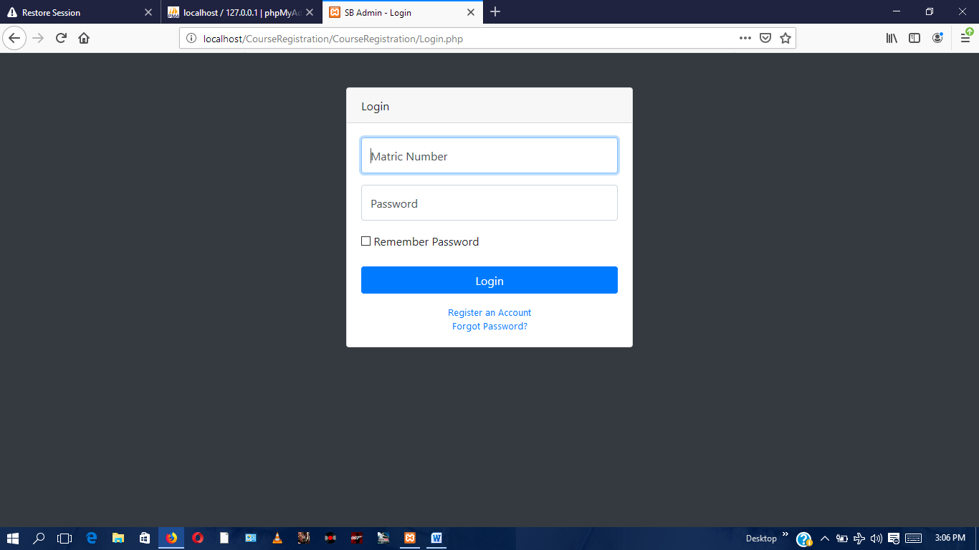

**Figure 8:** student login page

**4.7.3 Registration page**

This page allows a fresh student who needs to register for courses and view result create a new account.

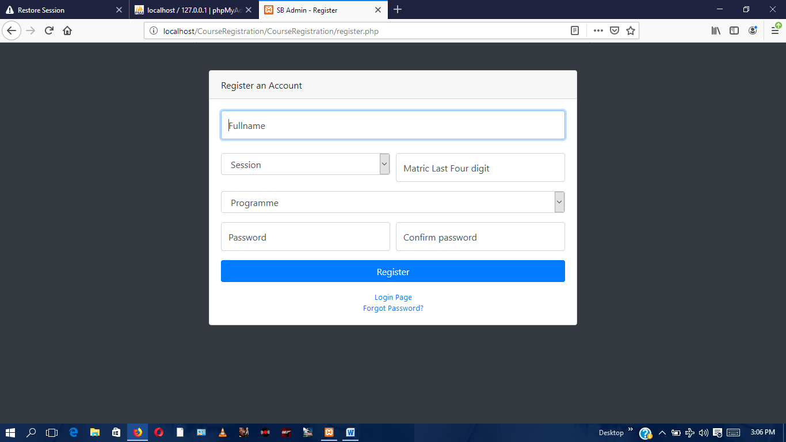

**Figure 9:** registration page

**4.7.4 Student dashboard**

This show the whole activities and progress which student have made on his account

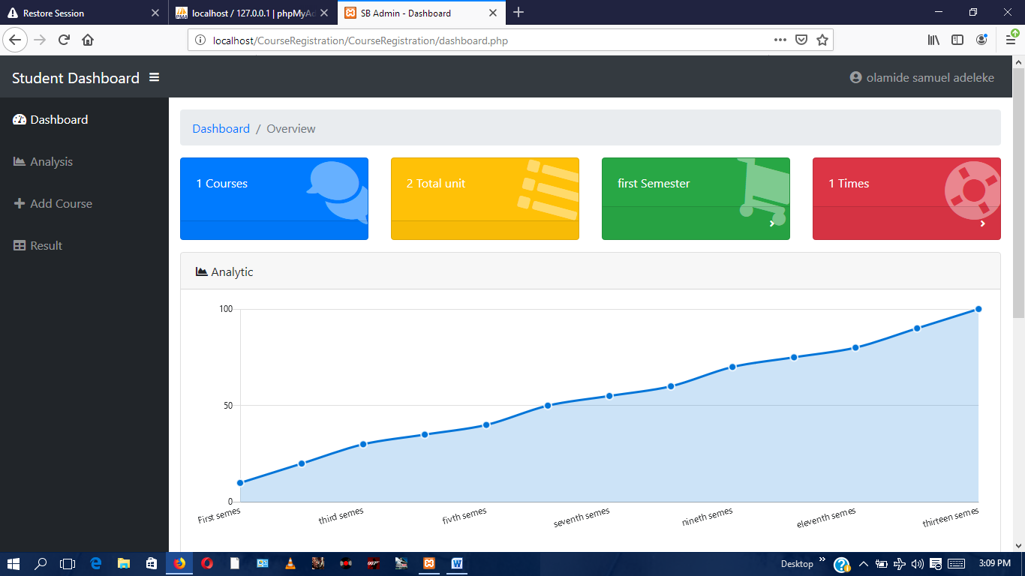

**Figure 10:** student dashboard

**4.7.5 Course registration page**

This is a page where student register for courses.

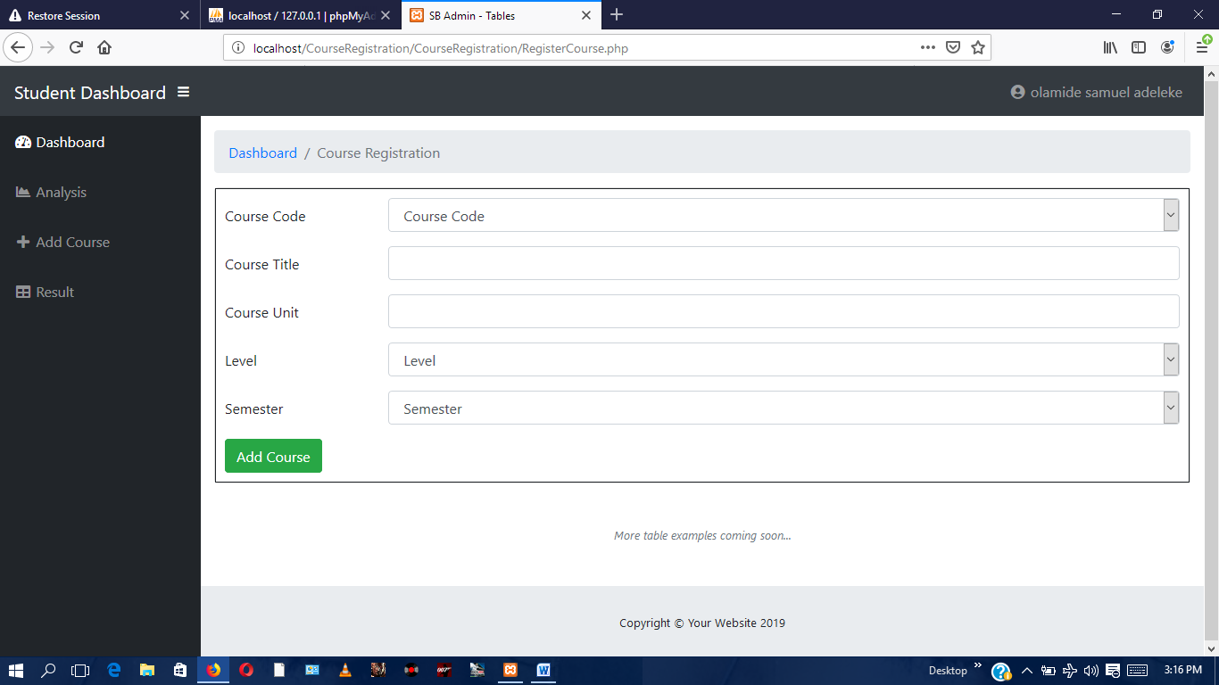

**Figure 11:** course registration page

**4.7.6 Result view page**

This is a page where student view there results.

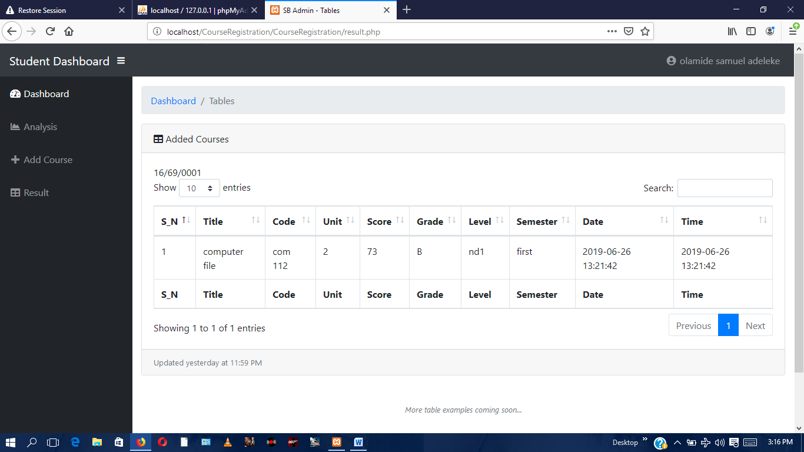

**Figure 12:** student result view page

**4.7.7 Admin login page**

This is a login page which can only be access by the administrator.

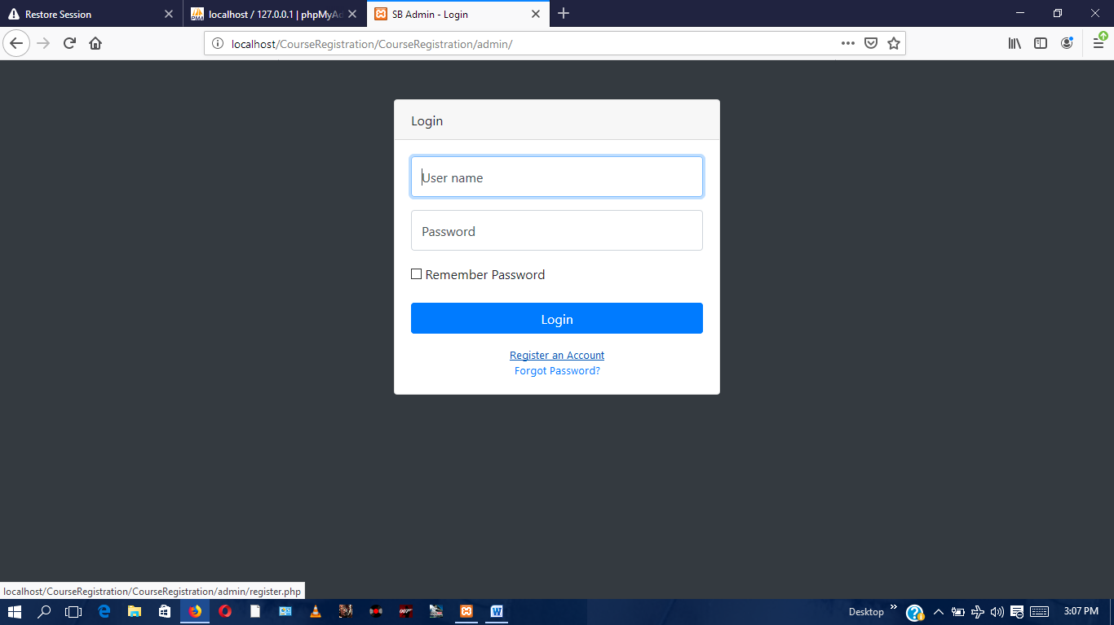

**Figure13:** admin login page

**4.7.8 Admin dashboard**

This shows the whole activities and progress which admin have made on students account.

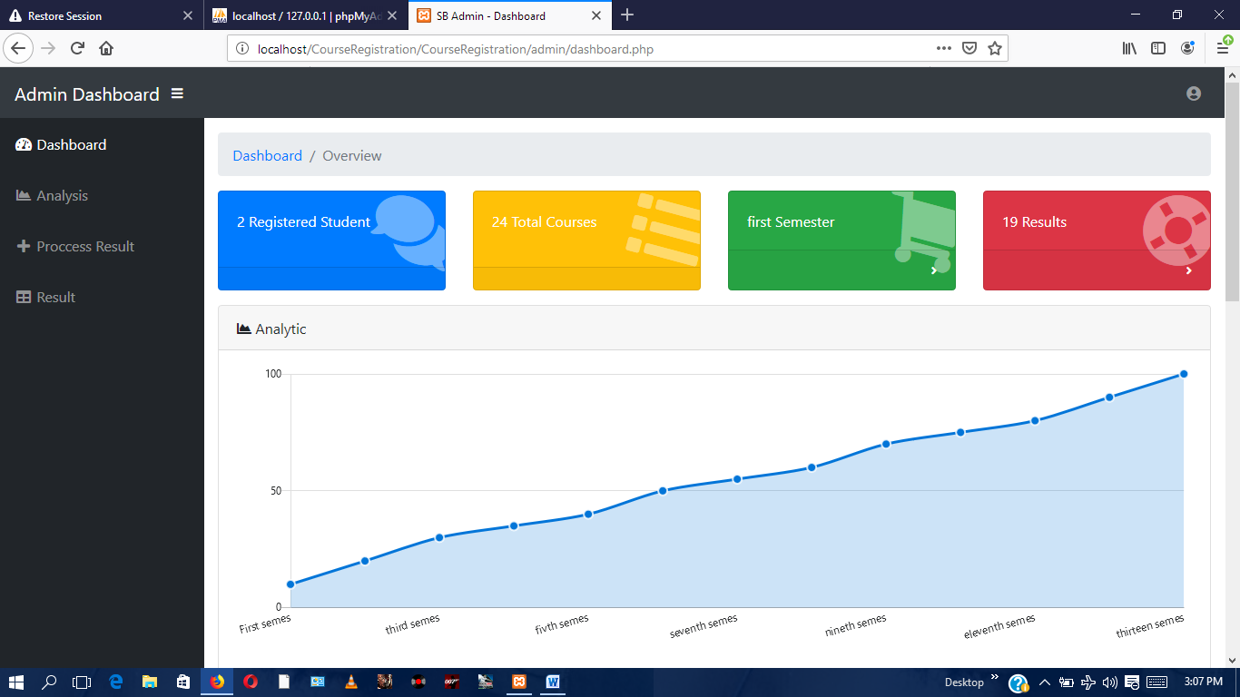

**Figure14:** admin dashboard page

**4.7.9 Result processing page**

This is a page where admin enters student score and been processed so that student can view on its own page.

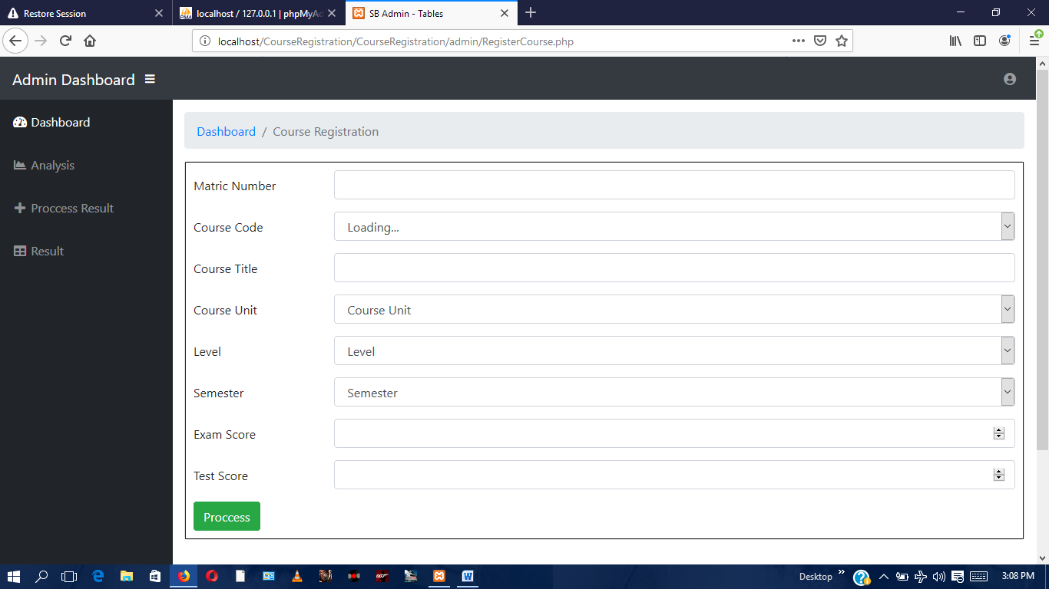

**Figure 15:** result processing page

**4.7.10 Result output page**

This is a page where admin is been able to view student result.

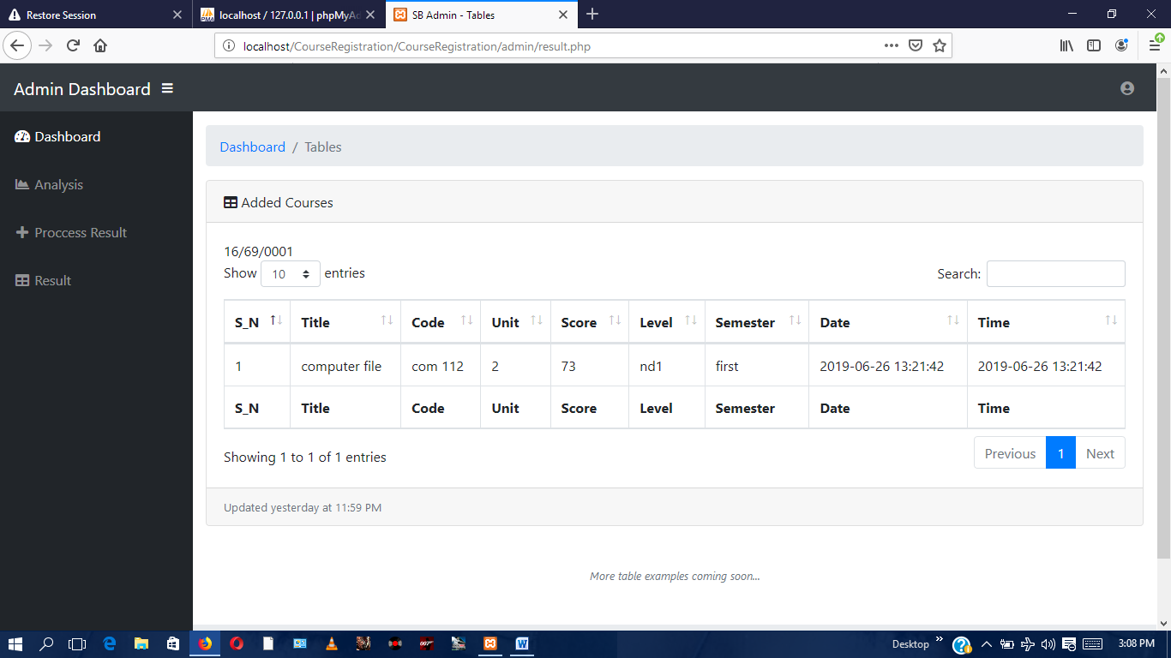

**Figure 16:** result output page

**4.8 DATABASE SCREENSHOT**

**4.8.1** **Student result table**

The figure below shows the screenshot of the student result view table where result been processed by the admin are been stored into .

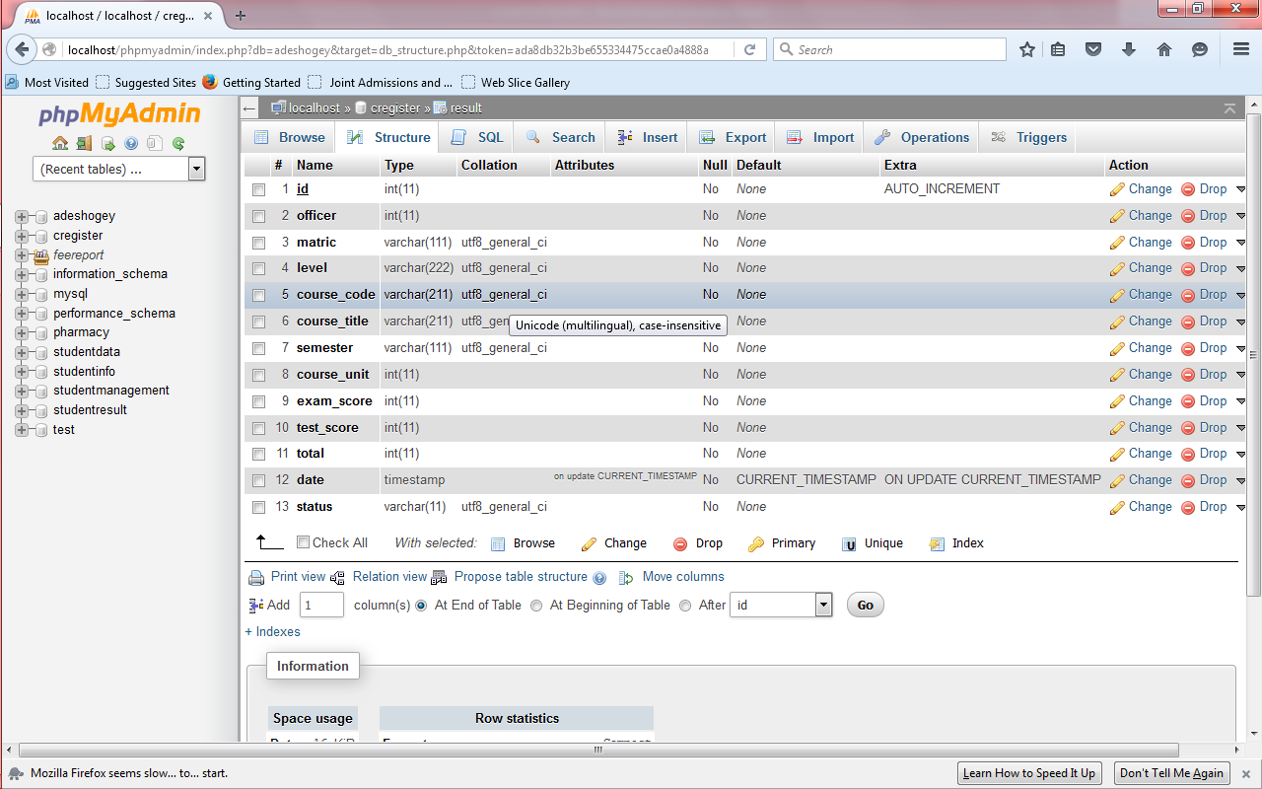

**Figure 17 :** student result table

**4.8.2 Student details table**

This figure below shows the screenshot of where registerd student details stored into .

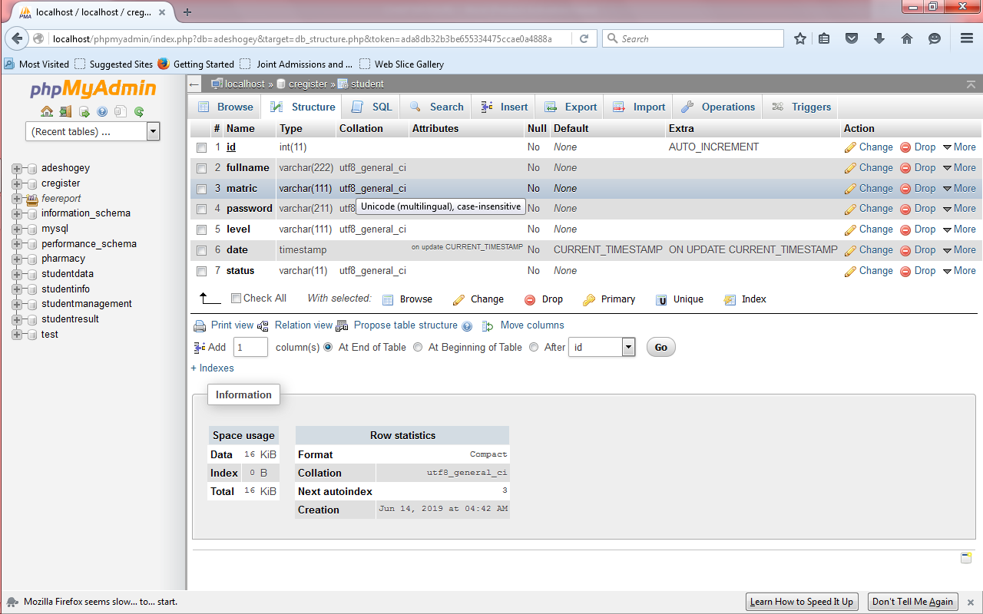

**Figure 18 :** student details table

**4.8.3 Course table**

The figure shows the screenshot of where student courses been registerd by student are been stored .

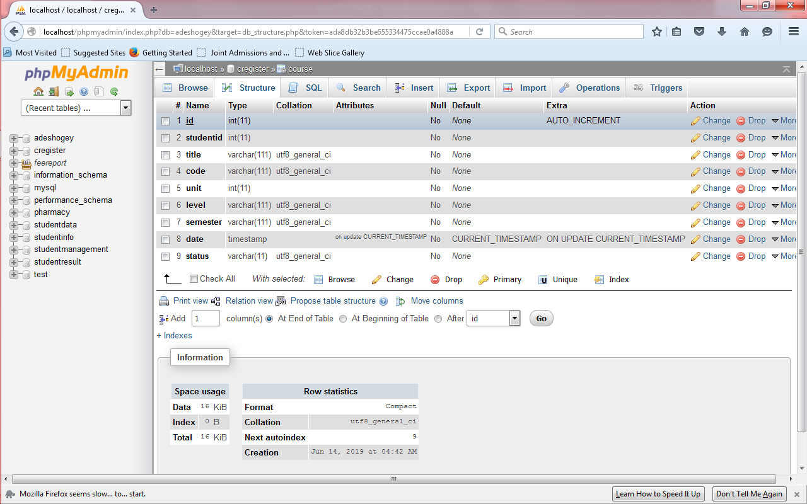

**Figure 19:** course table

**4.8.4 Admin table**

The figure below shows the screenshot of where newly registered admin are been stored .

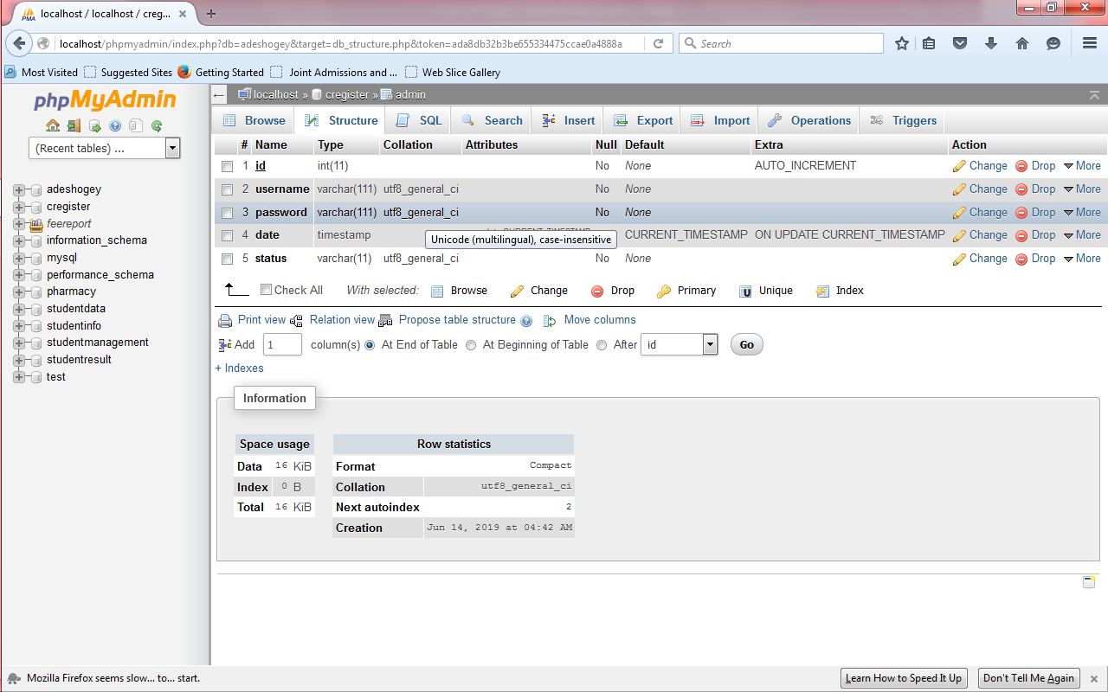

**Figure 20:** admin table

**CHAPTER FIVE**

**SUMMARY , CONCLUSION AND RECOMMENDATION**

**5.1 SUMMARY**

This research work focuses on the use of computer system with reference to course registration, result processing in the Polytechnic system. The work covers the manual system of opertions as regards the problems identified, stating the aims of the new system, stating the various specifications and then implementing the programs. The work was successufully developed using php, javascript scripting languages in an HTML environment, a user- friendly programming language, and the package was tested and improved upon which yields an automated course registration, result processing and result view.

The project work cannot be said to be perfect, but however, its benefits cannot be overemphasized. It has led to the improvement in the speed of processing operation, efficiency, accuracy and improved storage of data.

Realizing a project of this nature is very exciting. However, the students encounter a lot of problem which believe if looked into, will go a long way toward reducing the tension associated with the design implementation and construction of the project. In spite of the constraints encountered during the implementation of this project, the aim of my project is well accomplished.

Moreover, an attempt to accomplish this project has taken care of the delay between examination and result processing with minimum mistakes. This has also forced me to learn, practically, what is involved in the design and implementation or computerization of project (existing or non-existing). Finally, we wish to commend the polytechnic system and indeed the department of computer science for this project inclusion as a course that must be taken by graduating students it is a step in the right direction to withstand the future challenges in computing in companies, industries, institutions and the world at large.

**5.2 RECOMMENDATION**

The following recommendations based on the research findings are made to perhaps guide the department of computer science, Moshood Abiola Polytechnic in implementation of the on-line registration of course and result processing. Installation/implementation of all components of the network in the school is preceded by a project system analysis, which is aimed at attaining all the aims, objectives of the new system. There should be a genuine and functional need for the project and not a pre-supposed need for it.

If the feasibility study and report has been endorsed by the executive board, then it is recommended that a certified computer/information technology professional, analyst/ programmers should be employed to take over the management of the affairs of IT department of the school, so that any hitch could be effectively handled to ensure a smooth, run. A comprehensive program and refresher courses should be organized by the computer experts and operations in a network environment.

In the development of this project, which involves detail processing of student results, emphases were on subsystem course registration and result processing. Using computer science department as a case study with little amendments these subsystems can equally be used for other department in Moshood Abiola polytechnic. Other subsystems needed to be incorporated are the registry, the bursary, the library the medical and student’s affair subsystem. Each of these subsystems will require detailed analysis before their design in other to optimize the indispensable use of an automated polytechnic recording system.

**5.2 CONCLUSION**

Based on the achieved objective of this project and the experiences gained during its designed and implementation, Students should be exposed to serious practical exercise during the course of their studies. In this regard, the students of Computer Science & Information Technology should be made to write at least a working program with veritable results before graduating. This could be accomplished by providing more computers qualified lecturers in the department.

Tertiary institutions should computerize their result processing system for greater efficiency, neatness, and reliability. This will go a long way to save the student all the trouble they go through trying to get their results in one form or the other. Finally, the students’ project should be closely supervised and monitored to achieve more success.

**REFERENCES**

Aluko kling (1991). ‘Introduction of computer into information system for beginners’. spring

publishers, USA. COAN

Amigbogu (2002). ‘introduction to packages for data analysis ‘. Basic issues and Method,

Wisdom publishers Ibadan, Nigeria.

Bredan, P.K (1992). ‘Art of the Internet Beginner’s guide’. Prentice Hall, USA.COAN

Conference Series, Programming for the World Wide Web (2003): PP. 37 – 40.

Carlson Cole (1992). ‘ Hypertext tools for knowledge Workers’. spring publishers, USA.

Chidambaram L. Obilikwu Papert (1993). ‘Impact of Communication Medium and computer

support on group Perceptions and Performance’. Union press USA.

Cronin, M. (1995). ‘Doing Business on the Internet’. Van Nostrand Reinhold publishers, New

York.

Eloba French (1992).’Computer in school record keeping’. technical education today , vol. 3

no 182.

Feigenbaum Taylor. (1980).’Computerized education research’. New riders publishers,

Germany.

Gleason, T. (1994).’ The Information Super High way Oregon Quarterly Spring’. Burr Ridge

publishers USA.

Green, J.H. (2005).’ The Irvin Hand book of Telecommunication (3rd ed.)’ . Burr Ridge

publishers USA.

Huahuan Funk Anigbogu. (2003). ‘Factors affecting education processing ‘.Van Nostrand

Reinhold publishers, NewYork.

Isaac, S. and Michael W.B (2004). ‘Handbook of Research and Evaluation’. IDG publishers

Inc. Fosters City CA94404 USA.

Jeffrey, V. (2001).’ The Art and Science of web Design’. New riders publishers, Germany.

Manroe Balfore. (2011).’Education processing system ‘ .Burr Ridge publishers USA.

Mudric (1971) . ‘Concept of management information system’. union press publisher. Paper

Nworgu, B.G. (1991). ‘Educational Research’. Basic issues and Methodology, Wisdom

publishers Ibadan, Nigeria.

Roberts, L. (1967).’ Multiple Computer Network and inter – computer communication’. ACM

Gatlinbury conference.

Rusell M .(1987).’Computer database for educational system ‘. union press publisher .

Yourdon (1986).’ Computerized education research’. New riders publishers, Germany.

**APPENDIX**

<!DOCTYPE html>

<html lang="en">

<head>

<meta charset="utf-8">

<meta http-equiv="X-UA-Compatible" content="IE=edge">

<meta name="viewport" content="width=device-width, initial-scale=1, shrink-to-fit=no">

<meta name="description" content="">

<meta name="author" content="">

<title>SB Admin - Login</title>

<!-- bootstrap link -->

<link href="vendor/bootstrap/bootstrap.min.css" rel="stylesheet" type="text/css">

<!-- Custom fonts for this template-->

<link href="vendor/fontawesome-free/css/all.min.css" rel="stylesheet" type="text/css">

<!-- Custom styles for this template-->

<link href="css/sb-admin.css" rel="stylesheet">

<style media="screen">

nav{width: 40%;float: right;margin-top: 15px;}

li{ display: inline-block;margin: 15px;}

li a { padding: 10px; font-size: 15px; color: white; }

li a :hover{ text-decoration: none;color: red;}

h1{margin-left: 83px;}

</style>

</head>

<body class="bg-dark">

<header style=" width: 100%;

height: 60px; top: 0;position: fixed; left: 0;right: 0;">

<h1 style=" width: 30%;float: left; color: white; padding: 10px; ">C-Registration</h1>

<nav>

<ul>

<li> <a href="index.php">Home</a> </li>

<li> <a href="register.php">Join US</a> </li>

<li> <a href="Login.php">Login</a> </li>

</ul>

</nav>

</header>

<section style="background:url(images/banner.jpg) center; background-size: cover;

">

<div class="container" style="width:100%;height:688px;">

<h2 style=" position: absolute; top: 30%; color: white;">Mapoly Computer Science <br/>Student Course Registration.</h2>

</div>

</section>

<footer style=" padding: 10px; border-top: 1px solid; width: 100%; height: 20px; border: 1px solid;">

<h1 style=" width: 30%; float: left; color: white; padding: 10px; ">CRegistration</h1>

<nav>

<ul>

<li> <a href="index.php">Home</a> </li>

<li> <a href="register.php">Join US</a> </li>

<li> <a href="Login.php">Login</a> </li>

</ul>

</nav>

</footer>

<!-- Bootstrap core JavaScript-->

<script src="vendor/jquery/jquery.min.js"></script>

<script src="vendor/bootstrap/js/bootstrap.bundle.min.js"></script>

<!-- Core plugin JavaScript-->

<script src="vendor/jquery-easing/jquery.easing.min.js"></script>

</body>

</html>

Appendix

<?php session_start();

include 'connect.php'; ?>

<!DOCTYPE html>

<html lang="en">

<head>

<meta charset="utf-8">

<meta http-equiv="X-UA-Compatible" content="IE=edge">

<meta name="viewport" content="width=device-width, initial-scale=1, shrink-to-fit=no">

<meta name="description" content="">

<meta name="author" content="">

<title>SB Admin - Dashboard</title>

<!-- Custom fonts for this template-->

<link href="vendor/fontawesome-free/css/all.min.css" rel="stylesheet" type="text/css">

<!-- Page level plugin CSS-->

<link href="vendor/datatables/dataTables.bootstrap4.css" rel="stylesheet">

<!-- Custom styles for this template-->

<link href="css/sb-admin.css" rel="stylesheet">

</head>

<body id="page-top">

<?php require_once 'nav.php'; ?>

<div id="wrapper">

<!-- Sidebar -->

<?php require_once 'sidebar.php'; ?>

<div id="content-wrapper">

<div class="container-fluid">

<!-- Breadcrumbs-->

<ol class="breadcrumb">

<li class="breadcrumb-item">

<a href="#">Dashboard</a>

</li>

<li class="breadcrumb-item active">Overview</li>

</ol>

<!-- Icon Cards-->

<div class="row">

<div class="col-xl-3 col-sm-6 mb-3">

<div class="card text-white bg-primary o-hidden h-100">

<div class="card-body">

<div class="card-body-icon">

<i class="fas fa-fw fa-comments"></i>

</div>

<div class="mr-5">

<?php

$ids = $_SESSION['idf'];

$select = " select count(id) as sop from course where studentid = '$ids' ";

$query = mysqli_query($connnect,$select);

if(mysqli_num_rows($query)<1)

echo "0";

}else{

$sac = mysqli_fetch_array($query);

echo $sac['sop'];

} ?> Courses</div>

</div>

<a class="card-footer text-white clearfix small z-1" href="#">

<span class="float-left"></span>

<span class="float-right">

<!-- <i class="fas fa-angle-right"></i> -->

</span>

</a>

</div>

</div>

<div class="col-xl-3 col-sm-6 mb-3">

<div class="card text-white bg-warning o-hidden h-100">

<div class="card-body">

<div class="card-body-icon">

<i class="fas fa-fw fa-list"></i>

</div>

<div class="mr-5"> <?php

$idsch = '1';

$select = "SELECT SUM(unit) as al FROM course where studentid = '$ids' ";

$query = mysqli_query($connnect,$select);

if(mysqli_num_rows($query)<1){

echo "0";

}else{

$sac = mysqli_fetch_array($query);

echo $sac['al'];

} ?> Total unit</div>

</div>

<a class="card-footer text-white clearfix small z-1" href="#">

<span class="float-left"></span>

<span class="float-right">

<!-- <i class="fas fa-angle-right"></i> -->

</span>

</a>

</div>

</div>

<div class="col-xl-3 col-sm-6 mb-3">

<div class="card text-white bg-success o-hidden h-100">

<div class="card-body">

<div class="card-body-icon">

<i class="fas fa-fw fa-shopping-cart"></i>

</div>

<div class="mr-5"> <?php

$idsch = '1';

$select = " select semester as sop from course where studentid = '$ids' ";

$query = mysqli_query($connnect,$select);

if(mysqli_num_rows($query)<1){

echo "0";

}else{

$sac = mysqli_fetch_array($query);

echo $sac['sop'];

} ?> Semester </div>

</div>

<a class="card-footer text-white clearfix small z-1" href="#">

<span class="float-left"></span>

<span class="float-right">

<i class="fas fa-angle-right"></i>

</span>

</a>

</div>

</div>

<div class="col-xl-3 col-sm-6 mb-3">

<div class="card text-white bg-danger o-hidden h-100">

<div class="card-body">

<div class="card-body-icon">

<i class="fas fa-fw fa-life-ring"></i>

</div>

<div class="mr-5"> <?php

$idsch = '1';

$select = " select count(id) as sop from course where studentid = '$ids' ";

$query = mysqli_query($connnect,$select);

if(mysqli_num_rows($query)<1){

echo "0";

}else{

$sac = mysqli_fetch_array($query);

echo $sac['sop'];

} ?> Times</div>

</div>

<a class="card-footer text-white clearfix small z-1" href="#">

<span class="float-left"></span>

<span class="float-right">

<i class="fas fa-angle-right"></i>

</span>

</a>

</div>

</div>

</div>

<!-- Area Chart Example-->

<div class="card mb-3">

<div class="card-header">

<i class="fas fa-chart-area"></i>

Analytic </div>

<div class="card-body">

<canvas id="myAreaChart" width="100%" height="30"></canvas>

</div>

<div class="card-footer small text-muted">Updated yesterday at 11:59 PM</div>

</div>

<!-- DataTables Example -->

<div class="card mb-3">

<div class="card-header">

<i class="fas fa-table"></i>

Added Courses </div>

<div class="card-body">

<div class="table-responsive">

<table class="table table-bordered" id="dataTable" width="100%" cellspacing="0">

<thead>

<tr>

<th>S_N</th>

<th>Title</th>

<th>Code</th>

<th>Unit</th>

<th>Level</th>

<th>Semester</th>

<th>Date</th>

<th>Time</th>

</tr>

</thead>

<tfoot>

<tr>

<th>S_N</th>

<th>Title</th>

<th>Code</th>

<th>Unit</th>

<th>Level</th>

<th>Semester</th>

<th>Date</th>

<th>Time</th>

</tr>

</tfoot>

<tbody>

<?php $select_query = "select * from course where studentid = '$ids'";

$my_select = mysqli_query($connnect,$select_query);

$count = 0;

while($data = mysqli_fetch_array($my_select)){

$count ++;

?>

<tr>

<td><?php echo $count; ?></td>

<td><?php echo $data['title']; ?></td>

<td><?php echo $data['code']; ?></td>

<td><?php echo $data['unit']; ?></td>

<td><?php echo $data['level']; ?></td>

<td><?php echo $data['semester']; ?></td>

<td><?php echo $data['date']; ?></td>

<td><?php echo $data['date']; ?></td>

</tr>

<?php } ?>

</tbody>

</table>

</div>

</div>

<div class="card-footer small text-muted">Updated yesterday at 11:59 PM</div>

</div>

</div>

<!-- /.container-fluid -->

<!-- Sticky Footer -->

<footer class="sticky-footer">

<div class="container my-auto">

<div class="copyright text-center my-auto">

<span>Copyright © Your Website 2019</span>

</div>

</div>

</footer>

</div>

<!-- /.content-wrapper -->

</div>

<!-- /#wrapper -->

<!-- Scroll to Top Button-->

<a class="scroll-to-top rounded" href="#page-top">

<i class="fas fa-angle-up"></i>

</a>

<!-- Logout Modal-->

<div class="modal fade" id="logoutModal" tabindex="-1" role="dialog" aria-labelledby="exampleModalLabel" aria-hidden="true">

<div class="modal-dialog" role="document">

<div class="modal-content">

<div class="modal-header">

<h5 class="modal-title" id="exampleModalLabel">Ready to Leave?</h5>

<button class="close" type="button" data-dismiss="modal" aria-label="Close">

<span aria-hidden="true">×</span>

</button>

</div>

<div class="modal-body">Select "Logout" below if you are ready to end your current session.</div>

<div class="modal-footer">

<button class="btn btn-secondary" type="button" data-dismiss="modal">Cancel</button>

<a class="btn btn-primary" href="logout.php">Logout</a>

</div>

</div>

</div>

</div>

<!-- Bootstrap core JavaScript-->

<script src="vendor/jquery/jquery.min.js"></script>

<script src="vendor/bootstrap/js/bootstrap.bundle.min.js"></script>

<!-- Core plugin JavaScript-->

<script src="vendor/jquery-easing/jquery.easing.min.js"></script>

<!-- Page level plugin JavaScript-->

<script src="vendor/chart.js/Chart.min.js"></script>

<script src="vendor/datatables/jquery.dataTables.js"></script>

<script src="vendor/datatables/dataTables.bootstrap4.js"></script>

<!-- Custom scripts for all pages-->

<script src="js/sb-admin.min.js"></script>

<!-- Demo scripts for this page-->

<script src="js/demo/datatables-demo.js"></script>

<script src="js/demo/chart-area-demo.js"></script>

</body>

</html>